You can log in using the "Send me a one-time login code." when accessing the [branded app](https://economist.app.swapcard.com/) . Please check spam mailbox if you havent received an email from swapcard.

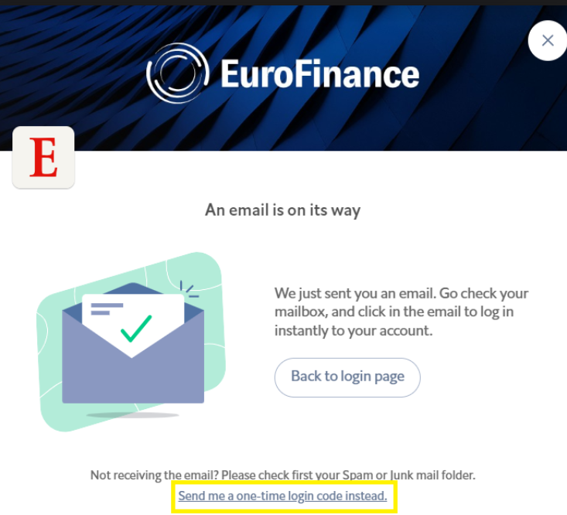

**Trouble shooting tips**

Here you will find simple fixes for the most common technical issues. Stop at any step where the issue is resolved. If you are logged into your account and certain features are not working properly, please try the following:

* Make sure you are **using Google Chrome or Mozilla Firefox** as a browser. [Clear your cache and cookies.](https://support.google.com/accounts/answer/32050?hl=en&co=GENIE.Platform%3DDesktop)
* Turn off any pop-up blockers. corporate firewalls and/or VPNs.Try to access the platform via an **incognito Google Chrome tab.**
* **Ensure your web browser audio and video preferences have been set to see sessions** o**n our platform.**
* Ensure that you see your name in the top right corner of the page and **not** "login."
* To log into your account and the event, you will need to do so via [login.swapcard.com](http://login.swapcard.com/). You will need to enter the email used for registration and the password you defined when logging in for the first time.